Fakenham Bowmen
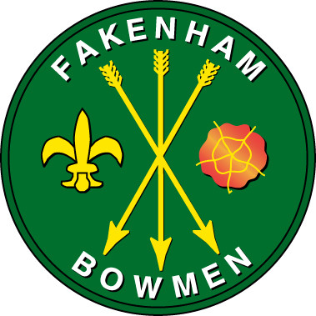
incorporating Fakenham Junior Bowmen

present our

“MAY LONGBOW MEETING”
BL-BS Rules
Sunday 3rd May 2026

Lady Paramount: t.b.c.
Judge Mr Geoff Barham
Assembly 9:00am
Shooting will commence at 9:15am
Round Two-Way Western
Entry Fee £9.00 seniors £4.00 juniors.
Organiser Mrs Elaine Burbidge Valcliff House, Sandy Lane, Fakenham. NR21 9ES
Email: mayday@fakenhambowmen.org.uk Phone: 01328 851848 / 07570 957982
NOTE: All Archers taking part must be members of ArcheryGB or BL-BS
Please note early start due to preparations for a Race meeting on Monday 4th May.

Presentations will take place as soon as possible after shooting is completed.

When you enter competitions the following information may be collected and shared with tournament organisers, scoring systems and other competitors for example target lists and results may be published: First Name, Surname, Gender, Bow style, Date of Birth / Age category, Email, Address, Phone number, Club (and ID), County (and ID), Region (and ID), Round (unless defined by age), Disabled (Y/N), Disability info.
See our website: www.fakenhambowmen.co.uk

Enter online or use the form below.
Pay our bank account: Number: 44684541 Sort code 52-41-29 Account name: Fakenham Bowmen. Use reference: “L-B meeting” or by cheque “Fakenham Bowmen” please.

* * * * * * * * * * * * * * * * * * * * * * * * * * * * * * * * * * * * * * * * * * * * * * * * * * * * *

“MAY LONGBOW MEETING” – Sunday 3rd May 2026

ENTRY FROM ………………………………………………………………………… (Title and Name)

Address: ………………………………………………………………………………………..….

……………………………………………………………………………………………………………

Email: …………………………………………………………………….. Phone: ………………………………………..

AGB membership no: ………………………… BL-BS? ……………………

Any Special requirements? Y / N If Yes, please give details:……….………………………………………………

Entry fee of £9 / £4 paid by BACS or cheque (enclosed) or PayPal.

Please return to Mrs E Burbidge, Valcliff House, Sandy Lane, Fakenham. NR21 9ES
Or email these details to: mayday@fakenhambowmen.org.uk

