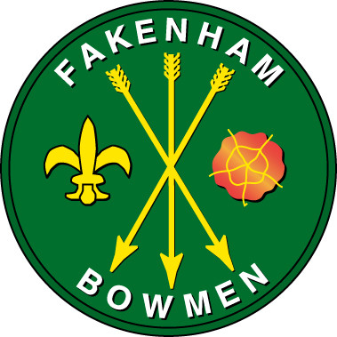

Fakenham Bowmen

Clout Weekend Results

13th & 14th October 2018

Fakenham Sports Centre, Hempton Road. NR21 7NY

Judges: Mr.G.Barham. Mrs K Lipscomb. Mr R Pilkington.

Organisers: Mrs Elaine Burbidge & Mrs Angela Williams
Valcliff House, Sandy Lane, Fakenham, Norfolk. NR21 9ES
Tel: 01328 851848
Email: mayday@fakenhambowmen.org.uk

Website: www.fakenhambowmen.org.uk

Saturday 13th October. Open FITA & Metric Double Clout
UK Record Status Metric Tassel Status
Lady Paramount: Claire Brown, Nottingham Building Society
Weather: Sunny and mild but with a strong, gusty wind.

Sunday 8th October. One-way Double GNAS Clout
Norfolk County & Visitors Clout Championships
UK Record Status Tassel Status
Lady Paramount: Claire Brown, Nottingham Building Society
Weather: Calmer but wet. Rain for most of the day.

Elaine & Angela on behalf of Fakenham Bowmen would like to thank
The Nottingham Building Society for their sponsorship and their representative, Claire Brown, for acting as Lady Paramount.
We also thank the Judges and all the archers for a good humoured and very enjoyable weekend, despite trying weather conditions.
We hope to see you again next year: 12th & 13th October 2019.

The full results accompany this…

